Cat.6A S/FTP Patch Cord
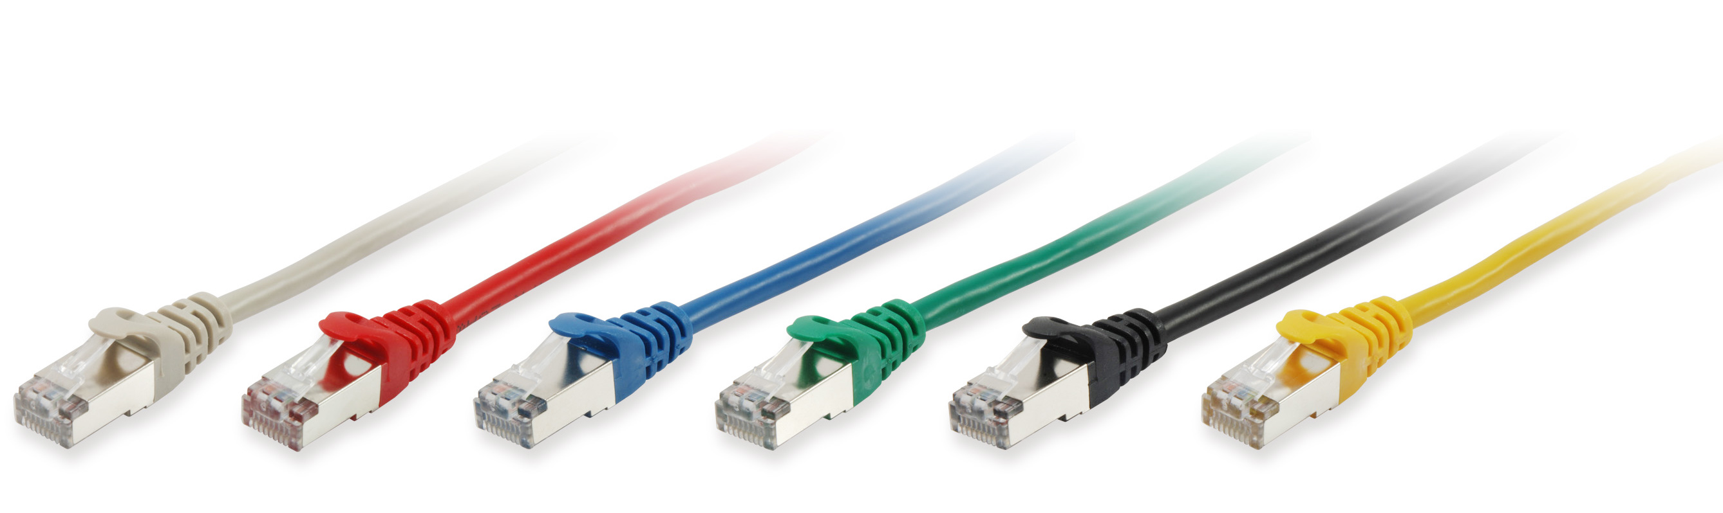

The equip® Cat.6A S/FTP Patch Cord is composed of preeminent materials and fully-examined to comply with industrial standards. Offering higher bandwidth and better signal-to-noise margin, the Cat.6A cable is able to deliver ultrahigh and error-free performance in the most demanding network environments, especially for the10G application.
l Key Feature
- 26AWG  - 500MHz  - Stranded  - PIMF (pairs in metal foil) | - Gold plated pins  - Molded boot  - Cable length printed on plug  - Halogen free LSZH

l Typical Applications
- IEEE 802.3: 10Base-T; 100Base-T; 1000Base-T ; 10GBASE-T
- IEEE 802.5 16 MB; ISDN; TPDDI; ATM
l Structure
Insulation
Bare Copper
Jacket
Mylar
Braiding
Al Foil

l Specification
Conductor | Material | Bare Copper
Conductor | Construction | 26AWG, 7/0.152 ± 0.005mm
Insulation | Thickness | MIN at any point: 0.2 mm / MAX AVG:0.35 mm
Insulation | Diameter | 1.05 ± 0.05mm
Insulation | Colors | Blue-White/Blue, Orange-White/Orange, Green-White/Green, Brown-White/Brown
Jacket | Material | LSZH
Jacket | Thickness | MIN at any point: 0.50mm / MAX AVG: 0.60mm
Jacket | Diameter | 6.1 ± 0.2mm

l Ordering Information
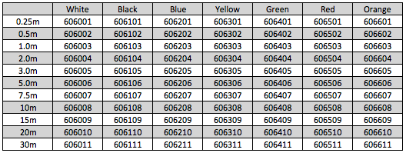

Packing: equip zip bag

